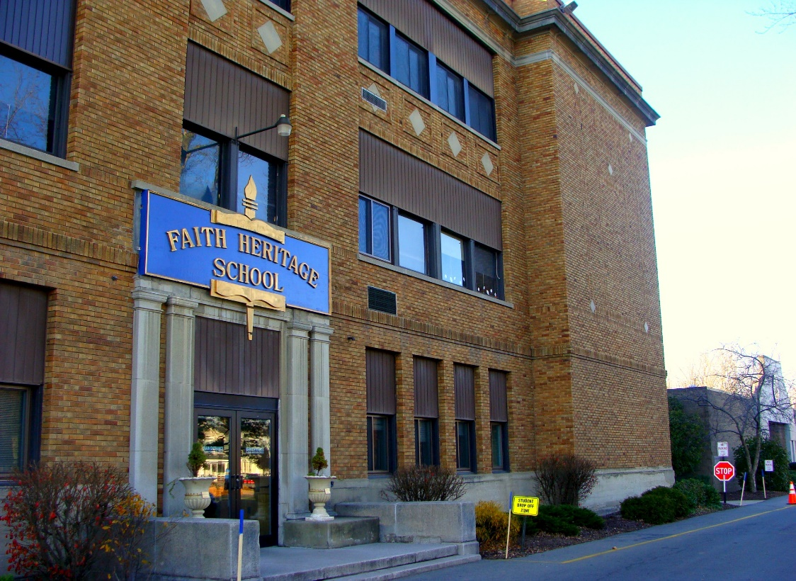

MINIMUM CAPACITY :-
The Minumum intake capacity
of students is between 350-620
children

LIBRARY :-
The Libarary is Available.

CANTEEN:-
The Canteen Facility is Available.

BOARDING :-
No availablility of boarding.

SPORTS :-
There are different categories
sports available.
Girls Volleyball
Boys Volleyball
Football

FAITH HERITAGE SCHOOL
SYRACUSE - SCHOOL

School Detail :-
Faith Heritage School is a private, non-denominational Christian, K-12 school in Syracuse, New York that was established in 1972. As of the 2003–2004 school year, its total enrollment was 557, with a student-to-teacher ratio of 14.3, according to NCES figures provided by the United States Department of Education.
Faith Heritage School exists to glorify God by providing a sound, Biblically integrated program in order to assist parents and churches in equipping students for Christian living and service within today’s changing world.
Students are becoming lovers of God who experience a close relationship with Jesus Christ, seeking above all things to Glorify His name and look forward to His coming

